EXPERIMENT 1
IOE SENSOR DATA ACQUISITION AND PREPROCESSING USING PYTHON IN GOOGLE COLAB
Aim
To acquire IoE sensor data, preprocess the dataset by checking missing values, removing duplicate records, normalizing the data using Min-Max Scaling, and visualize the normalized sensor values using Python in Google Colab.

Objective
- To create an IoE sensor dataset.
- To identify missing values in the dataset.
- To remove duplicate records.
- To normalize sensor values using Min-Max Scaling.
- To visualize normalized Air Temperature data.
Software Requirements
- Google Colab
- Python 3
- Pandas Library
- Matplotlib Library
- Scikit-learn Library

Theory
The Internet of Everything (IoE) connects people, devices, sensors, data, and processes to enable intelligent decision-making. Sensors continuously collect environmental data such as soil moisture, temperature, humidity, light intensity, and battery level.
Raw sensor data often contains inconsistencies such as duplicate records, missing values, and different measurement scales. Therefore, preprocessing is essential before analysis.
The preprocessing steps include:
- Creating the sensor dataset.
- Checking for missing values.
- Removing duplicate records.
- Normalizing data using Min-Max Scaling.
- Visualizing the processed data.
Normalization converts all values into the range 0 to 1, making different sensor readings comparable.
The Min-Max normalization formula is:
$$X_{norm}=\frac{X-X_{min}}{X_{max}-X_{min}}$$
where:
- X = Original value
- Xmin = Minimum value
- Xmax = Maximum value
Algorithm
- Import required Python libraries.
- Create the IoE sensor dataset.
- Convert the dataset into a Pandas DataFrame.
- Display the original dataset.
- Check for missing values.
- Remove duplicate records.
- Normalize all sensor values using MinMaxScaler.
- Display the normalized dataset.
- Plot the normalized Air Temperature graph.
- End the program.
Code
import pandas as pd
import matplotlib.pyplot as plt
from sklearn.preprocessing import MinMaxScaler

# Sample IoE Sensor Dataset
data = {
"Soil_Moisture": [45, 50, 55, 48, 52, 60, 58, 54, 49, 53],
"Air_Temperature": [26, 27, 28, 29, 30, 31, 29, 28, 27, 30],
"Humidity": [60, 62, 65, 64, 66, 68, 67, 65, 63, 66],
"Light_Intensity": [400, 420, 450, 470, 460, 500, 490, 480, 430, 450],
"Battery_Level": [95, 94, 93, 92, 91, 90, 89, 88, 87, 86]
}

# Create DataFrame
df = pd.DataFrame(data)

# Display Original Dataset
print("Original Dataset:")
print(df)

# Check Missing Values
print("\nMissing Values:")
print(df.isnull().sum())

# Remove Duplicate Records
df = df.drop_duplicates()

# Normalize Dataset
scaler = MinMaxScaler()
df[df.columns] = scaler.fit_transform(df)

# Display Normalized Dataset
print("\nNormalized Dataset:")
print(df)

# Plot Air Temperature
plt.figure(figsize=(8,5))
plt.plot(df["Air_Temperature"], marker='o')
plt.title("Normalized Air Temperature")
plt.xlabel("Sample Number")
plt.ylabel("Normalized Value")
plt.grid(True)
plt.show()
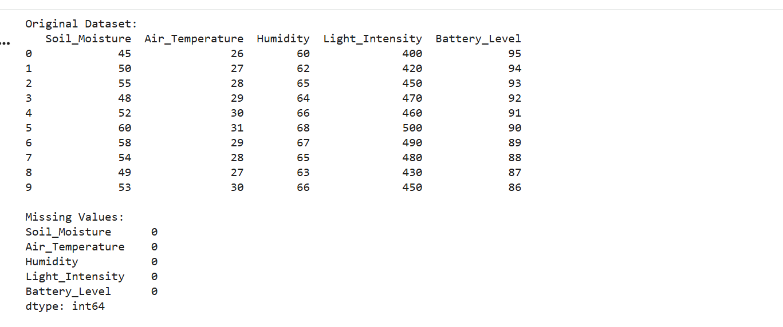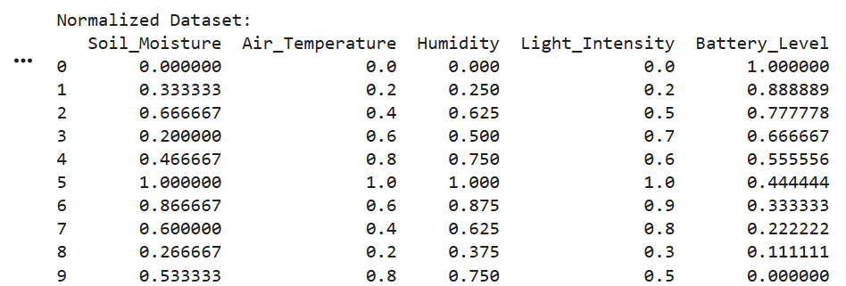
Output
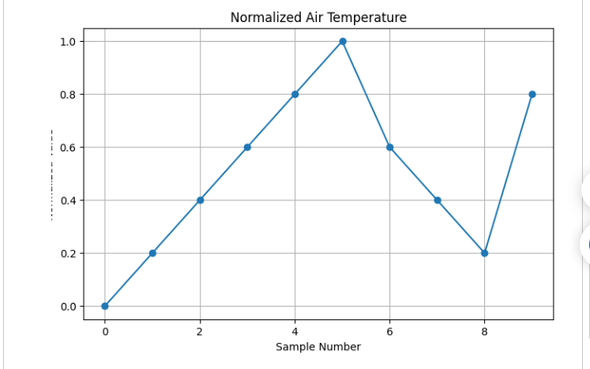
Result
The IoE sensor dataset was successfully created and preprocessed using Python in Google Colab. Missing values were checked, and no missing values were found. Duplicate records were removed successfully (if any existed). The sensor data was normalized using the Min-Max Scaling technique, converting all values into the range of 0 to 1. Finally, the normalized Air Temperature values were visualized using a line graph, enabling easy comparison and analysis of the sensor data

